**Problem Statement:**

You have successfully cleared your third semester. In the fourth semester you will work with inbuilt functions and user-defined functions.

**Tasks To Be Performed:**

1. Use the inbuilt functions and find the minimum, maximum and average amount from the orders table.

**Snippet:**

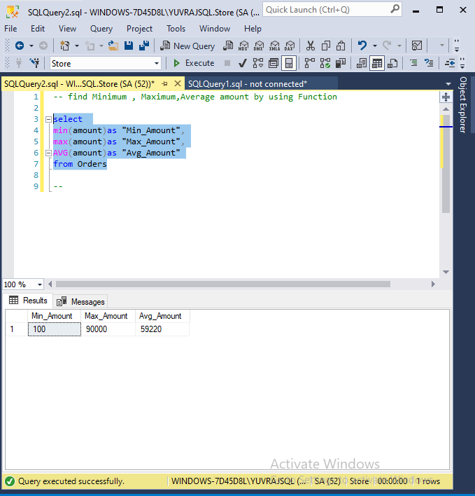

1. Use the case statement to check if 100 is less than 200, greater than200or equal to 200 and print the corresponding value.

**Snippet:**

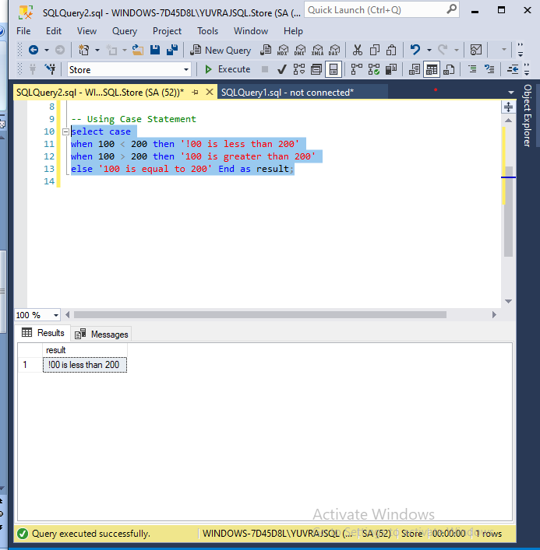

1. Create a user-defined function which will multiply the given number with10

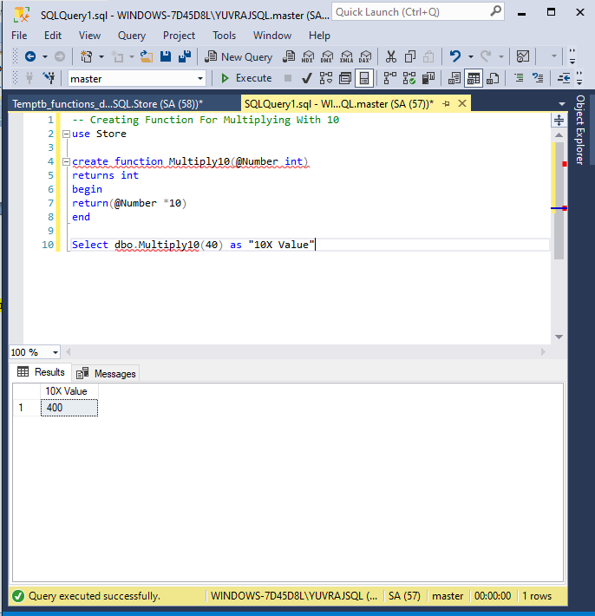

1. Using a case statement, find the status of the amount. Set the status of the amount as high amount, low amount or medium amount based upon the condition.

**Snippet:**

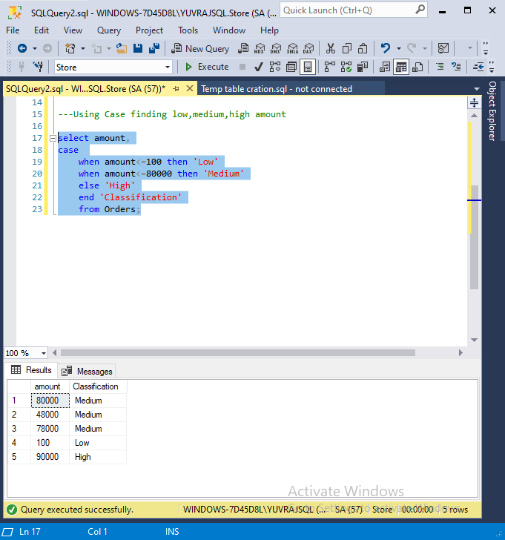

1. Create a user-defined function, to fetch the amount greater than then given input.

